Direct View Storage Tubes:
DVST terminals also use the random scan approach to generate the image on the CRT screen. The term "storage tube" refers to the ability of the screen to retain the image which has been projected against it, thus avoiding the need to rewrite the image constantly.
Function of guns: Two guns are used in DVST
- Primary guns: It is used to store the picture pattern.
- Flood gun or Secondary gun: It is used to maintain picture display.
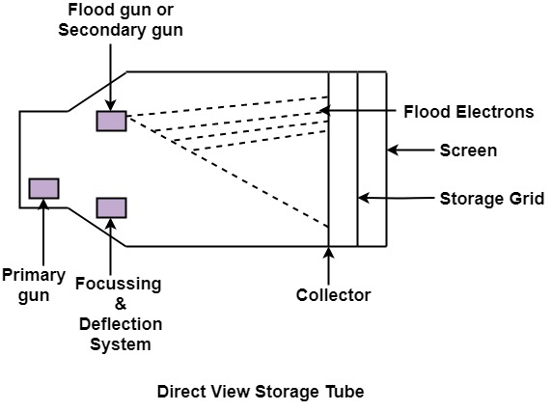

Advantage:
- No refreshing is needed.
- High Resolution
- Cost is very less

Disadvantage:
- It is not possible to erase the selected part of a picture.
- It is not suitable for dynamic graphics applications.
- If a part of picture is to modify, then time is consumed.

